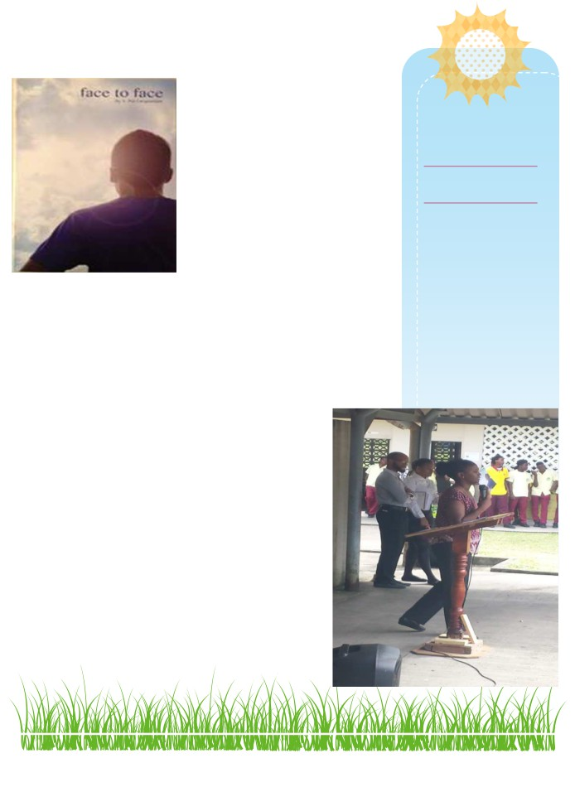

June 14th, 2017

Lifeline Gospel

Ministries
St. Lucia Report
Happy Summer Time Enjoy

Greetings in the Name of our Lord and Savior Jesus Christ. Greetings, Mendel and Pat Farquharson, along with the family/partners of Lifeline Gospel Ministries.

It is always with great pleasure I write this report. I thank God for the ministry and the opportunity to labor in the field of souls for Jesus. Thank you, again. I am pleased to serve you.

I presented the gospel and the face to face booklet at 3 Secon-
dary Schools for this school term, which marks the end of the school academic year 2016/17.
School Term 24th April—July 7th, 2017

1) Soufriere Secondary School
550 face to face booklets including 3 leaders guide booklets were distributed to students, teachers and the guidance department.
Amazingly, after I made the request to say the prayer with me , to accept Jesus as Lord and Savior, a counted number of students raised their hands; how-
ever I heard the entire student body repeat the sin-
ners/repentance prayer out loud, including the school’s principal. Praise God!

In the picture, at my back is the Principal (female) and the Vice Principal (male)

Prayer Points

• Salvation of students and
teachers in new school
year
• Continued boldness to
share the gospel and heath
for me and family
• Partners to assist with the
ministry in St. Lucia
• Continued open door at
schools
• Increase Financial bless-
ings for lifeline Gospel
Ministries.

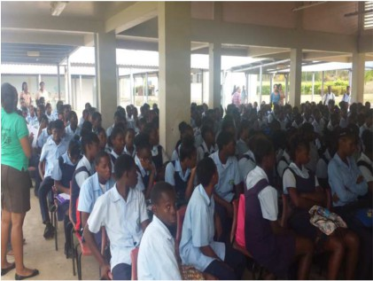
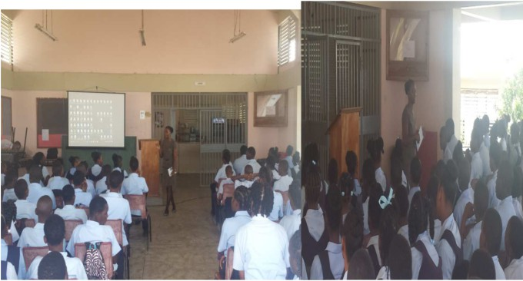

Anse Ger Secondary School: General Assembly

Every student said the
sinners prayer. (435 )
460 books were distributed students
and staff, including 3 leaders guide.
The students received the message of
biblical self- image very well. They re-
sponded by show of hands when I
questioned them about the big 5
negative statements in the book.
Students were shy to stand up to re-
ceive Jesus Christ as their savior, how-
ever, every student said the sinner’s
prayer. They eagerly prayed to re-
ceive Him as their Lord and three stu-
dents in particularly stood up to make
a public profession of wanting prayers
for healing been labelled with the
negative statements. I also gave the some stu-
dents a bible and bible materials.

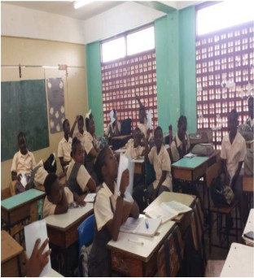
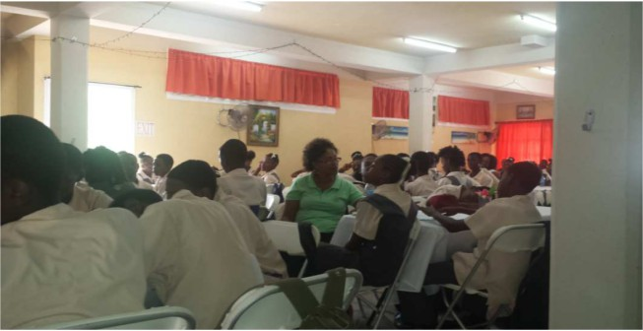

Micoud Secondary School Groups presentation

738 Students heard the gospel

I had the privilege of sharing the gospel to
the students of Micoud in groups. In every
group presentation of 30 and more students
I did, I saw the manifestation of God’s
power, students raised their desiring to
start life afresh and seeking God’s forgive-
ness for their sins. I was so blessed. Overall
a handful of students didn't pray the sinner’s
prayer. They were not forced to do so. God
is faithful.

Students were encouraged to guard their heart and read their bible. So much can be said on

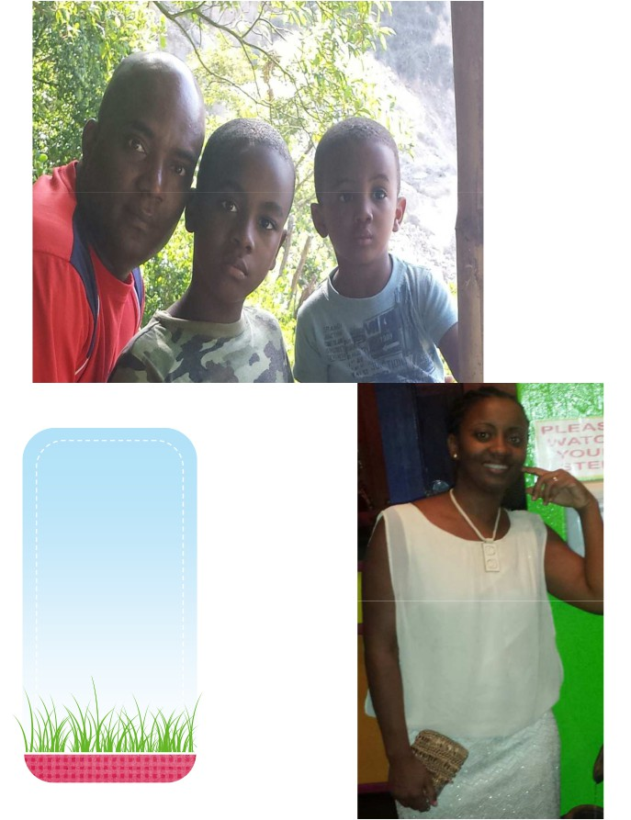

My Family and I

Ernie, my Husband and two sons,
Samuel 8 and Peter
2; both will soon be
9 and 3 in Septem-
ber.

Me at the
bottom.

Enjoy the
Summer
God bless you,
and we love and
appreciate you.

