## **Lifeline Gospel Ministries**

## 

Truly, Truly, I say unto you, he that believes on me has everlasting life. John

**PREPARED BY:** Mrs. Casilda Rosemond-Severin

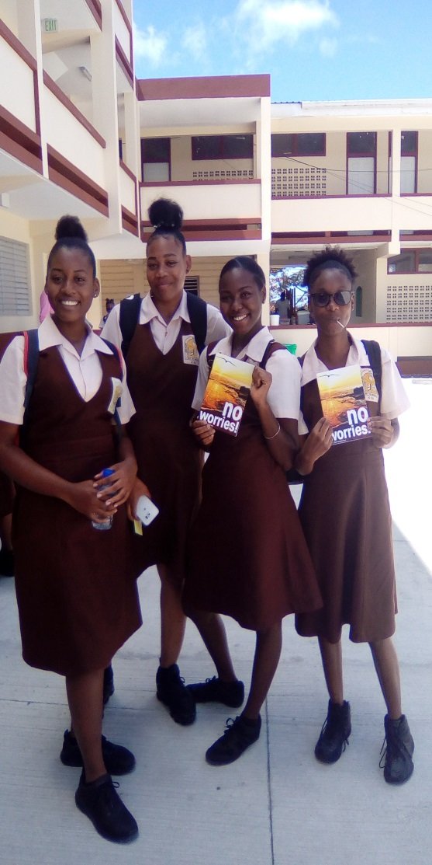St. Lucia Report: January—April 8th, 2019

I greet you in the Wonderful Name of our Lord and Savior Jesus Christ.

2019 is the year God has made and we shall rejoice and be glad in it.

This School term the ‘No Worries’ booklets were given to students

of the Choiseul Secondary School. The students were very

receptive to the gospel and the message that their Identity is found

ONLY in Christ Jesus. The school’s Principal and Vice-Principal

were both present and expressed this timely message to the

student body.

May we continue to 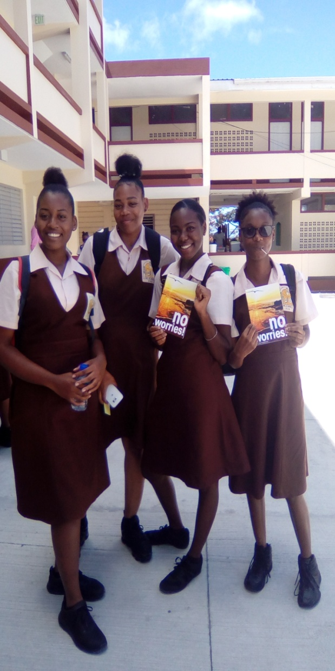 pray for God’s boldness to proclaim His truth

and that the students will take the time to read the booklet they

received. In 2018, this school received the Face to Face booklets

and now some of the students received the No Worries booklet.

There is a need for a Christian/Bible club to be created at this school,

so please pray for God’s favor and that the Principal will agree.

In addition, I was able to use the No Worries Leader’s Guide to counsel

a 16-year-old student who was seriously being bullied by her peers to the

point where she decided to quit school. The information in the

No Worries student’s copy was totally relevant and suitable to

the needs of this teenager. I thank God for having this booklet for

such a time as this, whereby the student can return to complete her

final exams. Praise God!



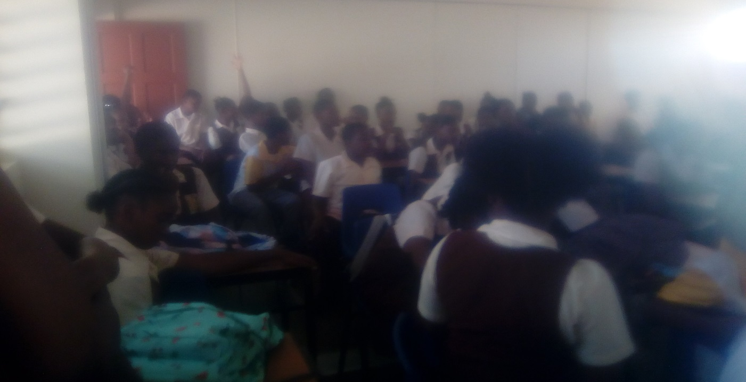

June, 2019

One class of 26 students from the Richfond Elementary School received Face to face Booklets for their 11 to 12 year old students. This group of students will be graduating to move unto High School in September, 2019. The school also requested the No Worriers Leaders guide for the teachers to conduct class sessions with the students. I will be following up with the school to find out how it benefited the students and if they need any assistance with the execution of the sessions.

**PRAYER POINTS:**

* Pray concerning the situations highlighted in the report.
* Pray for the Harvest - students will respond to the

gospel of salvation and be planted into a Bible

preaching Church.

* Pray for school officials to agree to having a Bible

club at their school.

* Pray for Lifeline Gospel ministry Founders

/workers/partners.

* Pray that God will provide a person (Believer) that

will work alongside me to labor for Him at the various

schools and in the local communities in St. Lucia.

* Pray for God’s spiritual covering, wisdom and

provision for me as I labor in the Lord’s vineyard.

